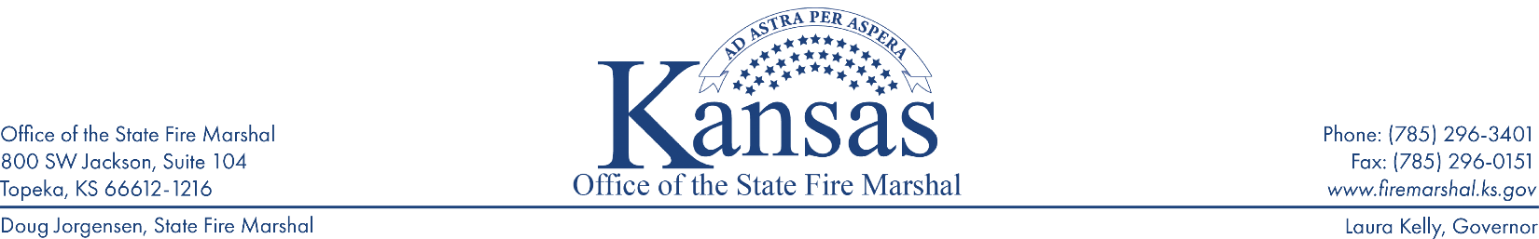
Requesting a Variance for Door Locks in Compliance with the 2018 Life Safety Code in RBC Facilities

K.S.A. 31-136 states: The state fire marshal shall have the power to grant exemptions from the application of specific requirements of regulations promulgated pursuant to this act. Any such exemption shall be granted only upon written request which clearly demonstrates that the enforcement of a specific requirement of a rule or regulation will cause unnecessary hardship to the petitioner, or that such exemption is necessary for the petitioner to take advantage of new methods or equipment of recognized adequacy which conforms to fundamental safety standards. The particulars of any exemption so granted shall be set forth in writing, and a copy thereof shall be retained in the office of the state fire marshal.

Variance requests should be submitted along with your initial plan of correction response. This request shall be in the form of a letter addressed to the State Fire Marshal (currently Doug Jorgensen).

The variance request letter must:
- Explain the necessity for having the door locks
- Address each of the requirements below and how the facility has met each requirement to comply with the 2018 edition of NFPA 101, Life Safety Code
- Contain a code footprint or scaled drawing of the facility, with the location of each door included in the variance
- Include any other pertinent information

Requirements that must be met in order to apply for a variance:
- Staff can readily unlock the doors at all times
- Building is protected by an approved automatic sprinkler system
- Provisions shall be made for the rapid removal of occupants by one of the following means:
  - Remote control of locks from within the locked building
  - Keying of all locks to keys carried by staff at all times
  - Other such reliable means available to staff at all times
- Only one locking device shall be permitted on each door
- Door lock automatically releases upon loss of power or activation of the fire alarm or sprinkler system

If you have questions, please contact the main office at 785-296-3401 and ask to speak with the Enforcement Officer assigned to your county.

