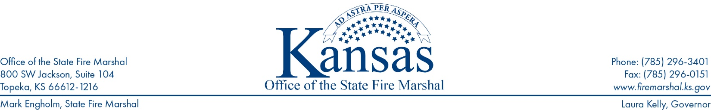
KSFM 2024-001 - KSFM Prevention Information Release

To: Nursing Home providers
Subject: Changes between 2000 Life Safety Code and 2012 Life Safety Code from CMS.
In 2016, the U.S. Centers for Medicare & Medicaid Services (CMS) adopted the requirements of the 2012 edition of the Life Safety Code (LSC). The LSC is developed by the National Fire Prevention Association, to provide fire protection requirements to provide a reasonable degree of safety from fires. The codes provide guidance related to construction, protection, and operational features to help with fire protection.

There are code requirements which changed because of the adoption of the 2012 edition of the Life Safety Code. The Kansas State Fire Marshal’s Office is sharing information to remind, and educate facilities on these changes, and how they continue to affect your facilities, and protect the lives of those who reside in your communities.

Door Locking Arrangements:

Currently under the 2012 LSC, if your facility provides care for cognitively aware residents, as well as residents who require special needs, and the residents are intermingled within the building, posting of the code at the exit doors is not allowed.

Previously under the 2000 LSC, Door locking arrangements, without delayed egress, were permitted in health care occupancies or portions of health care occupancies where clinical needs of the patients require specialized security measures for their safety, provided that staff can readily unlock such doors at all times (codes posted).

For reference, the currently adopted 2012 Life Safety Code states:

19.2.2.2.4 Doors within a required means of egress shall not be equipped with a latch or lock that requires the use of a tool or key from the egress side, unless otherwise permitted by one of the following:
(1) Locks complying with 19.2.2.2.5 shall be permitted.
(2)*Delayed-egress locks complying with 7.2.1.6.1 shall be permitted.
(3)*Access-controlled egress doors complying with 7.2.1.6.2 shall be permitted.
(4) Elevator lobby exit access door locking in accordance with 7.2.1.6.3 shall be permitted.
(5) Approved existing door-locking installations shall be permitted.

19.2.2.2.5 Door-locking arrangements shall be permitted in accordance with either 19.2.2.2.5.1 or 19.2.2.2.5.2.

19.2.2.2.5.1* Door-locking arrangements shall be permitted where the clinical needs of patients require specialized security
measures or where patients pose a security threat, provided that staff can readily unlock doors at all times in accordance
with 19.2.2.2.6.

(continue to page 2)

Fire Stopping and Plans of Corrections:
If you are cited during a survey for having penetrations in a smoke barrier wall, firewall, and/or floor-ceiling assembly, you must identify the specific fire stop product and the fire stop assembly that will be used to fix the rated wall penetrations.
STEP 1: Facilities will need to choose a fire stop assembly (a group of products that have been tested to work together to provide a rated barrier) and start using products from that assembly to fix the cited penetrations. The facility will then continue to use products from that fire stop assembly for future repairs.
STEP 2: Facilities will submit the fire stop assembly information, along with the specific fire stop product information to enforcement to clear any citations regarding rated penetrations.
STEP 3: Facilities will need to post the information regarding the chosen fire stop assembly on the rated walls impacted by the citation. This will ensure future penetrations are fixed accordingly.
NICET Certification Level Acceptance from CMS:
Fire alarm inspection, testing, and maintenance is required to be performed by qualified and experienced technicians.
Fire alarm companies can meet this requirement by being UL listed (everyone in the company meets a minimum qualification). Individual techs can be NICET II certified (NICET I can do limited system inspections but that does not include alarm systems tied into sprinkler systems). Individual techs may also be manufacturer certified – but only in that specific product line. In any of these scenarios, evidence of certification must be provided to the facilities and available for review during a life safety code survey.
If you would like to read more about NICET certification and fire alarm systems, please see:
https://www.nicet.org/certification-programs/electrical-and-mechanical-systems/fire-alarm-systems/
For questions and to assist you in complying with the requirements, the KSFM has a section on its website devoted to nursing home and similar facilities.
Please visit www.firemarshal.ks.gov/documentcenter In the “Resources” section, select Assisted Living Facilities.

###

