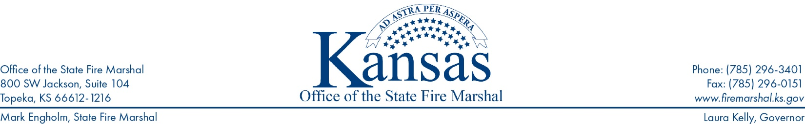
KSFM 2024-009- KSFM Prevention Information Release

Date: July 1, 2024
To: Assisted Living Facilities- (16 residence or more)
Subject: Emergency Plan/Fire Drill requirements

As the importance of safety in assisted living facilities continues to gain recognition, ensuring compliance with regulations such as those set forth by Kansas State Fire Marshal’s Office remains imperative. Among the various safety protocols mandated by KSFM, emergency procedures and fire drills stand out as critical exercises that directly impact the well-being of residents and staff alike. Understanding and implementing these requirements not only ensures regulatory compliance, but also enhances the overall safety and preparedness of assisted living communities.
Each facility shall have an emergency plan that will include special staff response, including the fire protection procedures needed to ensure the safety of any resident, and shall be amended as unusual needs are admitted to the home. Not less than every two months, all employees shall be periodically instructed with respect to their responsibilities and duties under the plan. A copy of the plan shall be readily available at all times within the facility.
Emergency plans and fire drill requirements are designed to simulate real-life emergency situations and test the effectiveness of a facility’s evacuation procedures. These drills serve as proactive measures to mitigate the risk of fire-related incidents and minimize potential harm to residents and staff members.
Here are some key elements of KSFM fire drill requirements and strategies for effectively meeting them:
Emergency Plan:
- All residents participating in the emergency plan shall be trained for proper actions in the event of a fire.
- Training shall include actions to be taken if the primary escape route is blocked.
- If a resident is given rehabilitation or habilitation training, actions to be taken in the event of a fire shall be a part of the training program.

Fire Drills:

- Fire drills shall be conducted not less than six times per year.
- On a Bi-Monthly Basis – Not less than two drills during the night when residents are sleeping.
- Fire drills shall be permitted to be announced to the residents in advance.
- Fire drills shall involve actual evacuation of all residents to an assembly point as specified in your emergency plan and shall provide residents with experience in egressing through all exits and means of escape.
- Residents who cannot meaningfully assist in their own evacuation or who have special health problems shall not be required to actively participate in the drill.

(continue to page 2)

Documentation and Evaluation:
- KSFM requires assisted living facilities to maintain detailed documentation of fire drills, including the date, time, scenario, and outcomes of each drill.
- Must keep one years’ worth of documents for inspector review.

Collaboration with Local Authorities:
- Assisted living facilities should collaborate with their local fire departments and emergency responders to enhance their fire drill preparedness. Engaging in joint drills or exercises with local authorities can provide valuable insights and foster cooperation between the facility and external response agencies. Establishing clear lines of communication and coordination ensures a more coordinated and effective response to emergencies, ultimately enhancing the safety of residents and staff.

Meeting KSFM emergency plans and fire drill requirements are not only a regulatory obligation, but also a fundamental aspect of ensuring the safety and well-being of residents and staff in assisted living facilities. By prioritizing fire drill preparedness and implementing training and evaluation processes, facilities can mitigate the risk of fire-related incidents and demonstrate their commitment to maintaining a safe environment for all.

For questions and to assist you in complying with the requirements, the KSFM has a section on its website devoted to the Assisted Living.
Please visit www.firemarshal.ks.gov/documentcenter In the “Resources” section, select Assisted Program.

###

