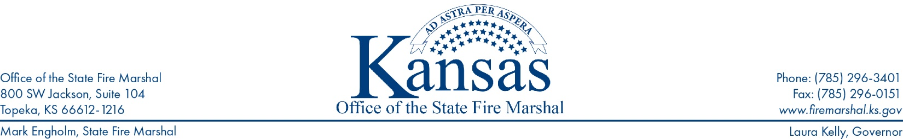
KSFM 2024-010 - KSFM Prevention Information Release
Date: July 15th, 2024
To: Facility Owners
Subject: Electrical Panel Clearance
Electrical panels are an essential component in any facility. When looking into electrical panel clearance safety, you need to start by looking at the requirements put in place by the national electric code, or NEC.
One of the main things that the NEC 110.26 specifies is that all electrical panels must have enough room around them that someone working on the equipment will have the room to safely access everything they need. This is necessary for all types of work including examination of the electrical panel, adjusting the electrical panel, servicing the electrical panel, and of course, performing maintenance on the electrical panel.
NFPA also focuses largely on reducing the risk of fires from occurring so that everyone can remain safe. Since electrical fires are one of the biggest risks that a facility can face, it should come as no surprise to find that the NFPA has requirements in this area.
Working spaces around electrical equipment shall be not less than 30 inches in width, 36 inches in depth, and 78 inch in height. If the service equipment is wider than 30 inches the minimum working space shall not be less than the width of the equipment. Storage of materials shall not be located within the designated work space.
At first glance many people would read the NEC electrical panel clearance requirements and assume that it simply means that you cannot put any additional equipment within the set amount of space. The fact is, however, that it goes well beyond that.
In order to remain in compliance with the relevant regulations, you cannot put anything in the space around an electrical panel. This means you cannot stack inventory in this area, you cannot park high-lows or other vehicles in the area, and you cannot use the area for temporary storage.
The area must not only remain completely clear of items at all times, but it also needs to be accessible. This means that you cannot leave an area around the electrical panel that is clear but have access to the area blocked off by stacks of boxes or other items.
To put it simply, you must have a policy in place that will ensure that any electrical panel in your facility can be easily accessed and worked on at all times. If there is anything that would prevent this or make it more dangerous, the chances are that you are in violation of the regulations and could get cited for it during an inspection.
A good start is to make sure that you have a written policy that everyone in the facility is aware of that makes it clear that inventory and other items may not be placed around any electrical panel.
Unfortunately, it is often difficult for people to remember exactly how much distance from a panel things can be. Even if they know how much room in inches is required, they may not be able to properly estimate how much room they are leaving when placing items in the area. One of the easiest and most effective ways to make sure that nobody places anything in the area around your electrical panels is to mark the area with floor marking tape. Measuring off the required distance around the electrical panels and putting down floor markings will make it extremely easy to see exactly where things can and cannot be placed.
(continue to page 2)

Some facilities will simply place the tape in a square around the panel to show the necessary distance that needs to be kept clear. Others will place the square around the area and then use diagonal stripes of floor markings to fill out the area, which makes it even more clear that nothing should be put in that place. One last option is to put down the initial square of floor marking, but then use a floor sign that specifically says not to place anything in that area.
All of these options will use effective visual communication standards to make sure that nothing is placed in the area directly around your electrical panels. Most facilities will already have floor marking tape on hand since it is one of the most commonly used safety items around. The tape can be placed down in the proper spots to make sure you get immediate results.
Recently a building took a lightning strike where the lighting went through the electrical panel, blew off the cover of the panel, melted the panel and ignited the combustible storage in front of the panel. (See evidence below).
These are some examples of the damage this can cause.

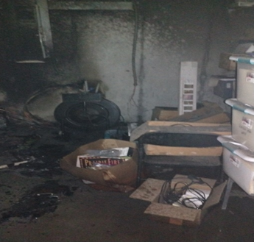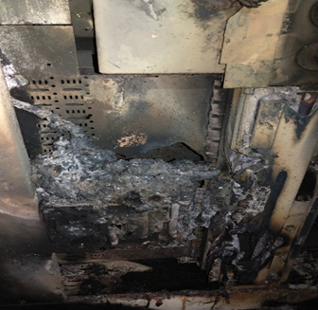

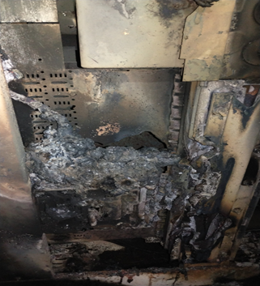

For questions and to assist you in complying with the requirements, the KSFM has a section on its website devoted to the Prevention Program.
Please visit www.firemarshal.ks.gov/documentcenter In the “Resources” section, select Prevention Program.

###

